

{



Introduction

 Mumbai is the commercial capital of India.

 Mumbai developed a highly diversified infrastructure.

 With its diverse society, comes diverse infrastructure which decides the quality of living.

 When one moves to a new city like Mumbai, is where to find a

good area to build and grow prosperously.

 The purpose is to help people in exploring better facilities around their neighborhood.



Business Problem

The questions I aim to answer in this project are the following:

1. *List and visualize all major parts of Mumbai City with top existing infrastructure.*
2. *What are the best locations in Mumbai as per infrastructure?*
3. *Which areas have the potential for the development of infrastructure of different kinds?*
4. *Which all areas lack the infrastructure facilities?*
5. *What is the best place to stay within a city for all vital infrastructure facilities?*



 For this project we need the following data:



Data acquisition and cleaning

1. Mumbai Pincode ( Scraped from web source)
2. Mumbai City data ( Geospace Data on Mumbai Pincode)
3. Different infrastructures in each neighborhood of Mumbai City data (Foursquare API)



# Methodology

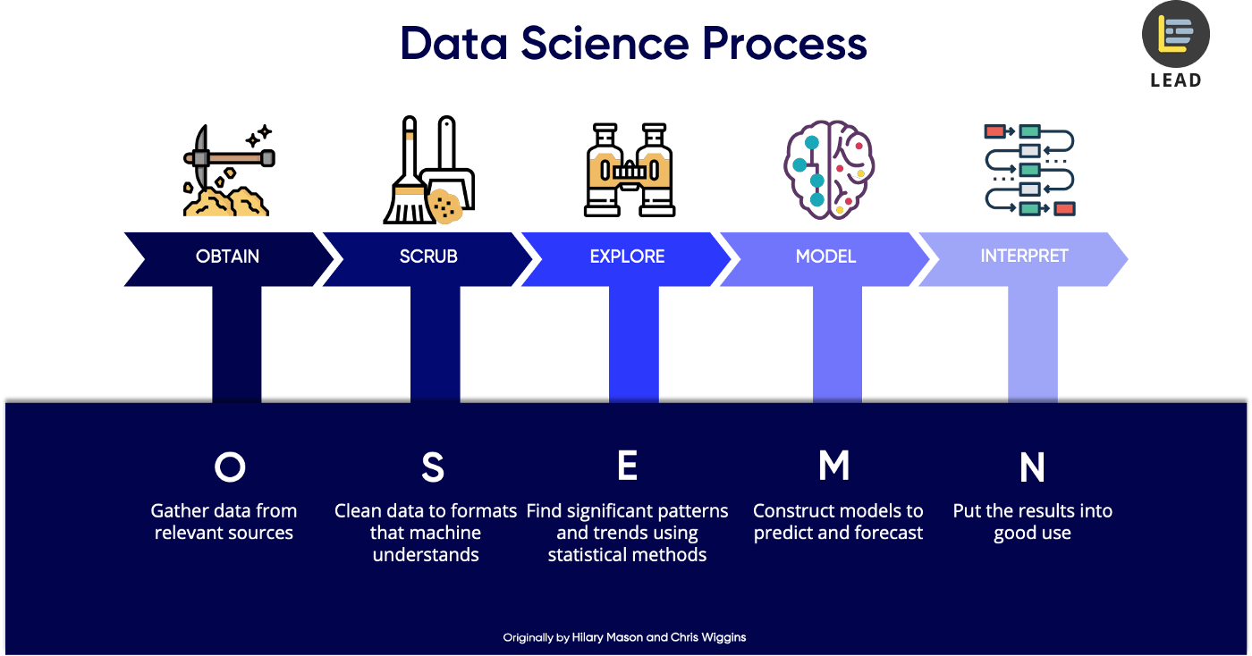

Credit is provided below the image



# Results

* 1. *Display the top existing infrastructure for each Postal Office in Mumbai.*

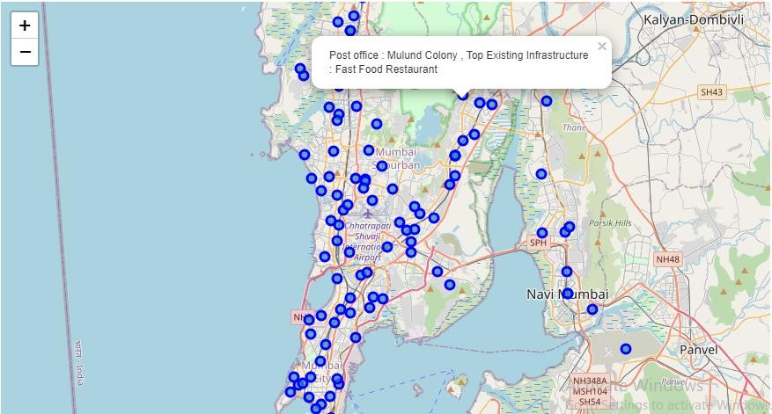



# Results

* 1. *What are the best locations in Mumbai as per infrastructure?*

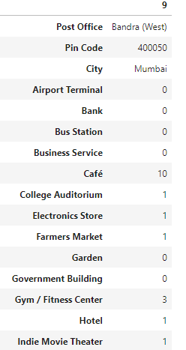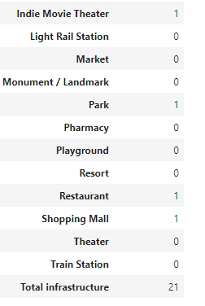



# Results

* 1. *Which all areas lack the infrastructure facilities?*

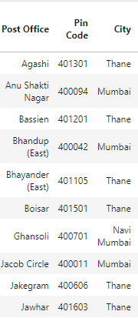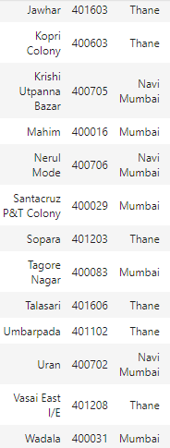



# Results

* 1. *Which of your choice areas have the potential for the development of infrastructure of different kinds?*

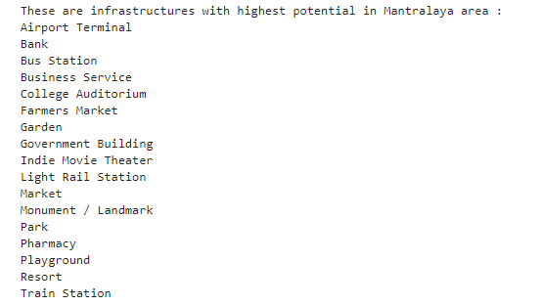



# Results

* 1. *What is the best place to stay within a city for all vital infrastructure facilities?*

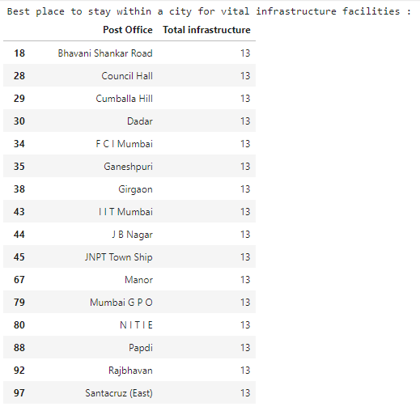

# Clustering Based On Total



Infrastructure

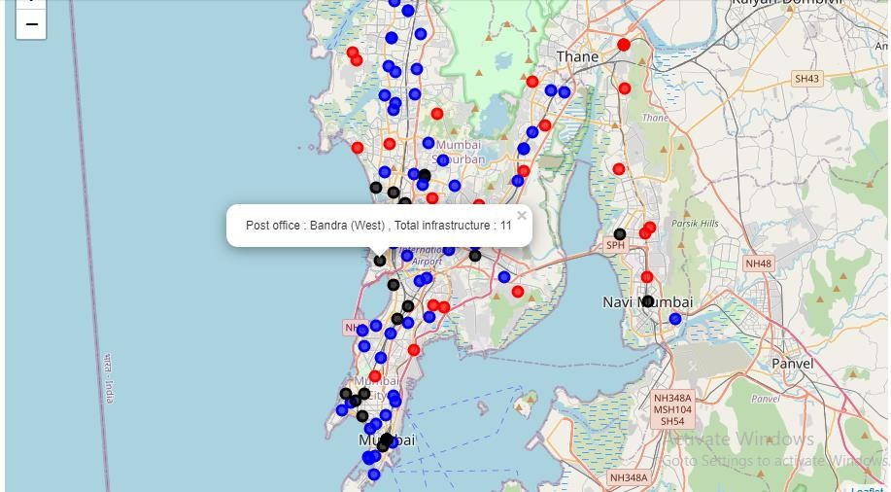

* **Cluster 1** (Red): Neighborhoods with a low number of infrastructures.
* **Cluster 0** (Black): Neighborhoods with a high number of infrastructures
* **Cluster 2** (Blue): Neighborhoods with a moderate number of infrastructures.



Discussion

 Bandra (West) is the best location in Mumbai as per infrastructure, with 10 Café boosting the number.

 19 postal offices are the best postal office area for essential variety

infrastructure.

 Most of the infrastructures are concentrated in the Southern areas of Mumbai city, with the highest number in cluster 0.

Recommendation



 Recommendation from Clustering :

 Cluster 1 with little to no competition - To open new infrastructures.

 Cluster 2 with moderate competition and supporting adequate no. of infrastructures – Ideal place to live prosperously and open unique infrastructures.

 Cluster 0 which already has a high concentration of infrastructures. – To settle in city and tough market to open new infrastructures.



Conclusion and future work

 This project made use of the free Sandbox Tier Account of Foursquare API - Limitations as to the number of API calls and results returned.

 Finding of these project will help relevant stakeholders i.e. **business developers** regarding the best locations to open a new infrastructure.

 The project also provides **visitors and immigrants** to the city regarding new postal office areas for growth and living prosperously.

Thank You !!!

-- Rohit Kumar Singh

( MAY 2020 )